
INDIAN INSTITUTE OF INFORMATION TECHNOLOGY DESIGN AND MANUFACTURING KURNOOL
Jagannathagattu, Kurnool-518008.

Date: 10.09.2026

Sub: Invitation for quotation for procurement of “Stainless Steel Plate Racks”- Reg.
***
Indian Institute of Information Technology Design and Manufacturing Kurnool invites bids for procurement of “Stainless Steel Plate Racks”
- Quotation submission procedure:
The bid is to be submitted in soft copy by Email in Pdf Protected files at the following mail id – _chiefwarden@iiitk.ac.in .
No manual document will be accepted. All documents should be submitted by email Password Protected PDF File. The subject of the mail should be “Bids for procurement of Stainless Steel Plate Racks”. The covering mail should indicate the contact details i.e. Mobile Number of the bidder. The password will have to be revealed only on communication from IIIDM mail (chiefwarden@iiitk.ac.in ) on the date & time of Opening of bid. The mail will be sent for password at the time of opening of bids. The bids shall be opened on 17th September 2026 at 3PM. Interested bidders may attend the opening of the bid. The bids will be opened and evaluated by the Committee appointed by Institute.
- Terms and conditions :
1. The bidders need to send the Quotations by email to above mentioned emails.
2. The soft copy of the quote should be password protected. The mobile number of the signatory on the quotation should be mentioned in the email, who will be contacted for the password at the time of opening of the quotation. Passwords will not be revealed before that by the bidder.
3. Last date & time for submission of quotations is on or before 17th September 2026 at 2PM.
4. Eligibility Criteria:
- Bidder shall have supplied same product with similar specifications to reputed Educational Institutes/Companies. Copy of Contract/P.O. shall be submitted as proof.
- Bidder shall submit a copy of self-attested GST Registration certificate.
- Compliance of the Technical Specifications and terms & conditions: A self-declaration on the letterhead of the bidder stating that they comply with all the required technical specifications and the terms & conditions.
- Bidders shall have OEM Authorisation and a self-attested copy is to be attached.
- Compliance of GFR Rule 144 (xi): The bidder shall not be from a country sharing land border with India and if the bidder is from a country sharing land border with India the bidder should have been registered with the competent authority as per orders of DIPP OM No. F. No. 6/18/2019-PPD dated 23rd July 2020, and MoCI Order No. P-45021/112/2020-PP (BE II) (E-43780) dated 24th August 2020 and subsequent amendments/orders. A declaration shall be submitted with the bid as per format given in Annexure–1.

- Additional Terms and conditions :
  - Scope: Supply, Installation & Commissioning
  - Warranty: __1 year____________________
  - Offer validity: _30_ days
  - Material to be delivered within 30 days from the day of issue of P.O. LD charges@1% per week or part thereof for delay in supply shall be applicable when Delivery Period extension is given.
  - Prices shall be inclusive of all taxes & charges for IIITDM Kurnool.
  - Original GST Invoice duly signed and stamped are to be submitted.
  - Payment will be made within 15 days from the date of final acceptance of the material.
  - For evaluation of offers, total wise comparison will be carried out.
  - Bidders shall submit their quote considering scope and all the terms & conditions, additional charges of any kind will be paid.
  - This bid is also governed by latest GTC issued by GeM.
- Format of Quotation: Bidders shall submit quotation as per given format in Annexure – 3.

Reference Image
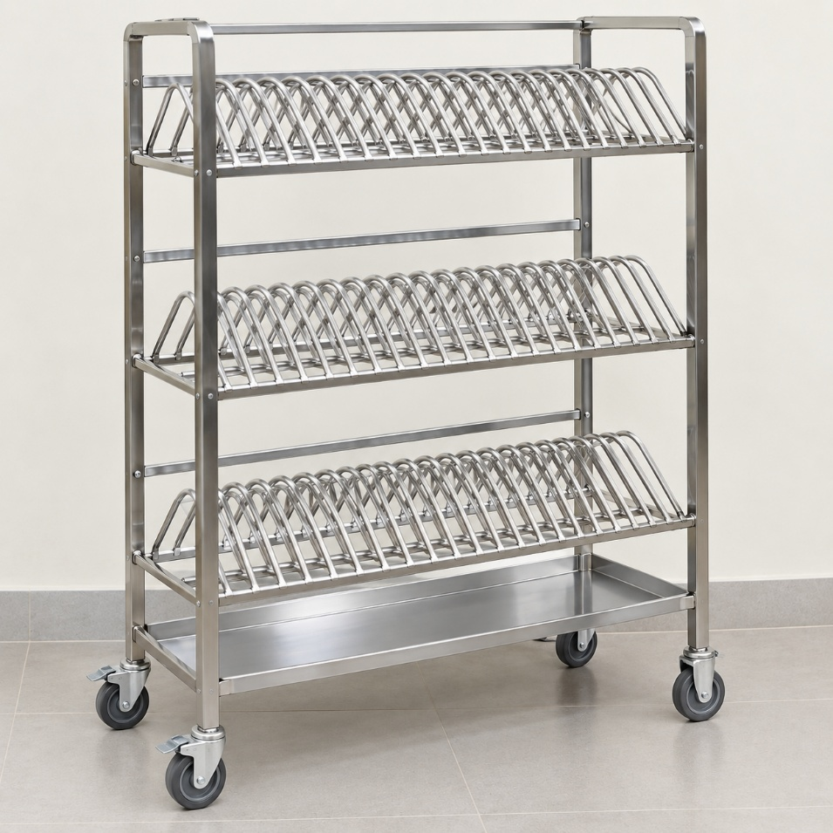

Annexure – 1

(To be given on the letterhead of the bidder)
No.______________________ Dated: ________________
CERTIFICATE
(Bidders from India)
I have read the clause regarding restrictions on procurement from a bidder of a country which shares a land border with India and hereby certify that Our Company/I am not from such a country.
OR (whichever is applicable)
(Bidders from a Country which shares a land border with India)
I have read the clause regarding restrictions on procurement from a bidder of a country which shares a land border with India and hereby certify that I from ___________________ (Name of Country) and the Company has been registered with the Competent Authority. I also certify that I fulfil all the requirements in this regard and is eligible to be considered. (Copy/ evidence of valid registration by the Competent Authority is to be attached)

Place: Signature of the Tenderer Date: Name & Address of the Tenderer with Office Stamp

Annexure – 3
Quotation format
(ON letterhead of vendor)

Name of the Vendor:
GST No.:
Address:

Contact No.
Email ID:
SI. No. | Description of the required items with specifications | Product Quoted (Make and Model along with specifications)* | Quantity | Unit Price inclusive of GST | GST % | Total Inclusive of GST
1. | Stainless steel Plate rack  To keep plates of  size 11” x 15” and  weight of plate ~550gms  -- capacity 120-130 plates  -- 4 to 6 shelves (shelve size should be morethan the plate to freely keep the plate)  -- drainout tray  -- movable with wheels  -- height is not more than 6.5 feet  --Corrosion-resistant  --Industrial grade  -- high quality  - including transport and installation |  | 12
Total Price (In figures):
Total Price (In words)
* Attach a separate sheet, if required
Quoated Product Specification and reference image has to be enclosed along with the bid.

Sign & Stamp of vendor

